Holiday Promotional Plan

Below are sample marketing promotions created by a client of mine and her team. Thank you, Crystal Madril of Madril Hair Design in Boise Idaho, for being open to sharing this with everyone. As you go through this be sure to edit this to add your own product lines and treatments, as necessary.
For the images, Crystal found them on Adobe Stock and then edited them with the Canva App.
Feel free to let these ideas empower your holiday season so that we can capture important opportunities and finish the year strong!
Be sure to track each promotion weekly to gauge progress. Cheerlead, coach and be the energy of these programs for them to work.
Enjoy the ideas and Nancy and I wish you a Happy Holiday season!

Steve Gomez

Pre-Book -
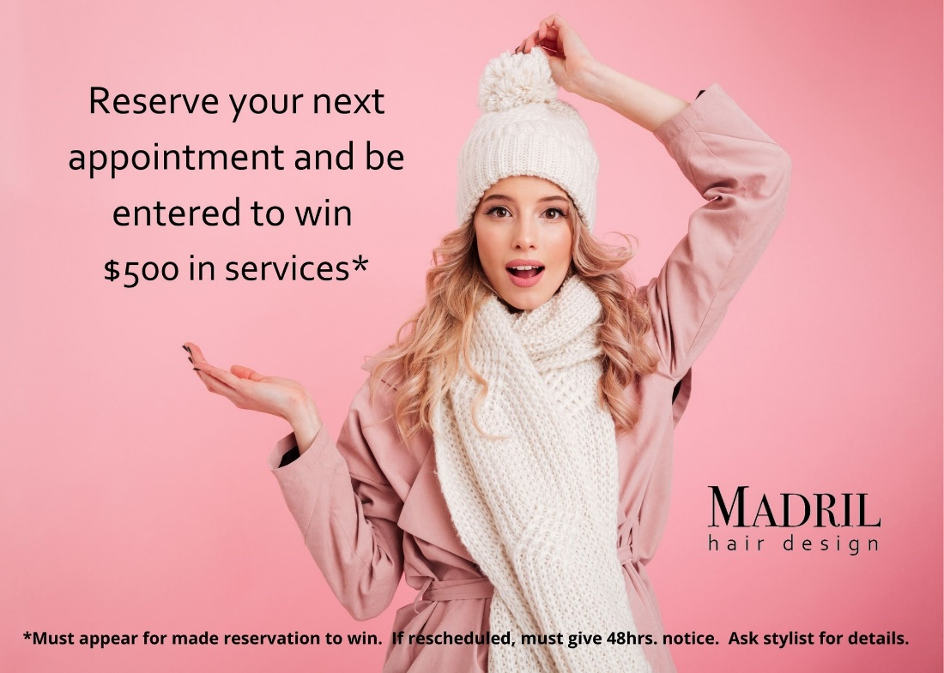
Promotion Title: Pre-book Promo
Month: Nov/Dec
Start date: Nov. 1st
End date: Dec. 31st
Category (internal/external): Internal
Description: Guests Pre-book their next appointment and are entered to win a $500 gift certificate towards services
What:
  - Guest Incentive: “$500 in services”
    - Reserving their next appointment enters guest for a chance to win a $500 gift certificate for services only.
  - Stylist Incentive: “$500 in services”
    - Promotes guests coming back more regularly and incorporating prebooking into their routines
  - Rules:
    - Guest will receive Gift Certificate at their pre-scheduled appointment
    - Guest may split the $500 total into multiple Gift Certificates to give as gifts
    - Guests have up to a year to use
    - Cannot be used to purchase retail
    - Can be used with any technician
    - May enter up to 3x (book 3 reservations)
  - Winner notified on December 31st at 5:00pm
To Do List:
- Make Signage:
  - Internal = 14 - 5 x 7’s
    - Design = team member (Once complete put initials in red to verify completion)
    - Print & Place = (team member)
  - External = Facebook, Software E-blast, Newsletter
    - Facebook Write up/Post = (team member)
    - Software E-blast = (team member)
    - Newsletter = (team member)
- Track Pre-books = (team member)
- Make Gift Certificate = (team member)
- Do the Drawing = (team member)
- Video for social media = (team member)
- Sign off with date and initials once task has been completed _________
Actual Goal: Promote guests coming back more regularly and incorporating prebooking into their routines. Growing Stylists’ books.
Assigned Individuals:
Team Member = Signage
Team Member = Newsletter, Facebook posts, E-blasts, IG stories, tracking
Team Member = Make videos
Team Member = Tracking (Prebook entries)
Resources:
  - Distributor
  - Adobe suite
  - Canva
  - Premiere – Instagram planner
  - Facebook
  - Software
Supplies Needed:
  - Ink
  - Frames
  - Photo paper
  - Gift Card
Expenses:
  - Ink $10

  - Photo paper $6.45

  - Adobe Suite

  - Cost of server payout $250
Total expense = $266.45
Incentive:
One raffle ticket put in a drawing for appointment made. Up to 3.
Assigned Progress Tracker: ____________________________

Service -
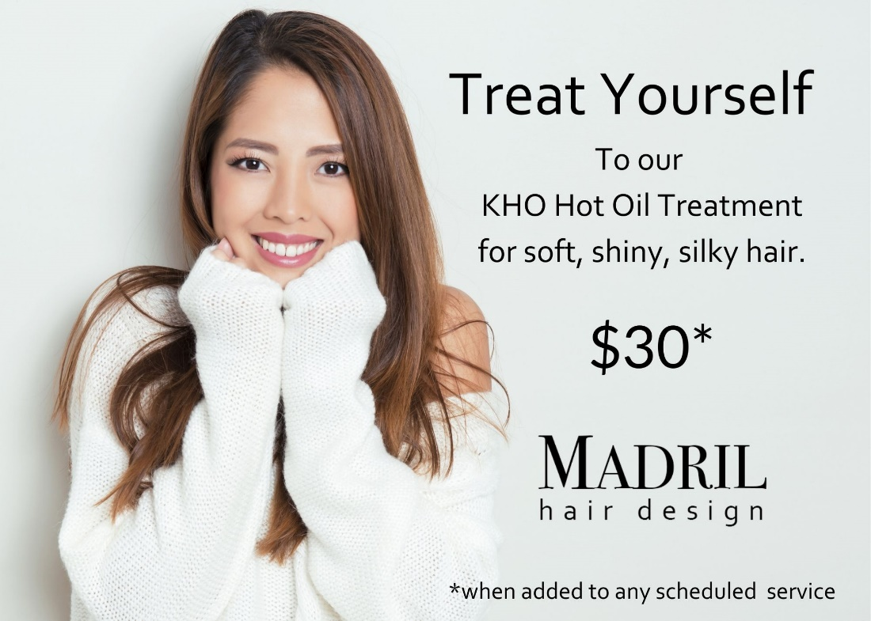
Promotion Title: Service Promo – “Treat Yourself”
Month: Nov/Dec
Start date: Nov. 1st
End date: Dec. 31st
Category (internal/external): Internal & External
Description: Receive a KHO Hot Oil Treatment when added to any hair service
What: Service Promo – “Treat Yourself”
  - Promote KHO Hot Oil Treatment to guest to help them look their best for the holidays. ($30 when added to a service) Guest Incentive: “Treat Yourself”
    - Great hair and a whole lot of pampering
  - Stylist Incentive: “Treat Yourself”
    - Stylists introduce KHO Hot Oil Treatments to their guests and make more money now and in the future

  - Rules:
    - Must be in conjunction with a scheduled service
    - Guest may book as a stand-alone service if booked with a blow-dry style
  - Instruction for treatment:
    - Shampoo with KHO Lustrous Shampoo or shampoo of choice
    - Blot hair dry
    - Add KHO Masque to hair and disperse through hair with scalp massage
    - Pump a few pumps of KHO Hair Treatment Oil to the hair and comb through ends with the L’ANZA Treatment Comb
    - Put on a processing cap (not the big ones, hair will not get heat on ends)
    - Put under Halo on Condition for 10 minutes
    - Rinse with warm water
    - Proceed with next service
To Do List:
- Make Signage:
  - Internal = 14 - 5 x 7’s
    - Design = (team member)
    - Print & Place = (team member)
  - External = Facebook, Software E-blast, Newsletter
    - Facebook Write up/Post = (team member)
    - Software E-blast = (team member)
    - Newsletter = (team member)
- Make reminder sheets for tribe
  - Type up Instructions = (team member)
  - Print up promo description and put in a binder for front desk = (team member)
    - Laminate instructions for backbar = (team member)
- Video for social media = (team member)
- Sign off with date and initials once task has been completed _________
Actual Goal: Up sell services and make more money. Introduce guests to KHO Masque in hopes of selling at home care.
Assigned Individuals:
(Team member) = Signage (Crystal)
(Team member) = Newsletter, Facebook posts, E-blasts, IG stories, tracking
(Team member) = Make videos
(Team member) = Tracking (Prebook entries)
Resources:
  - Distributor
  - Adobe suite
  - Canva
  - Premiere – Instagram planner
  - Facebook
  - Software
Supplies Needed:
  - Ink
  - Frames

  - Photo paper

  - Gift Card
Expenses:
  - Ink $10

  - Photo paper $6.45

  - Adobe Suite

  - Cost of Products Used $36
Total expense = $52.45
Incentive:
Guests = soft, shiny, healthy hair
Service providers = $$$
Assigned Progress Tracker: ____________________________
Retail – Holiday Box Sets
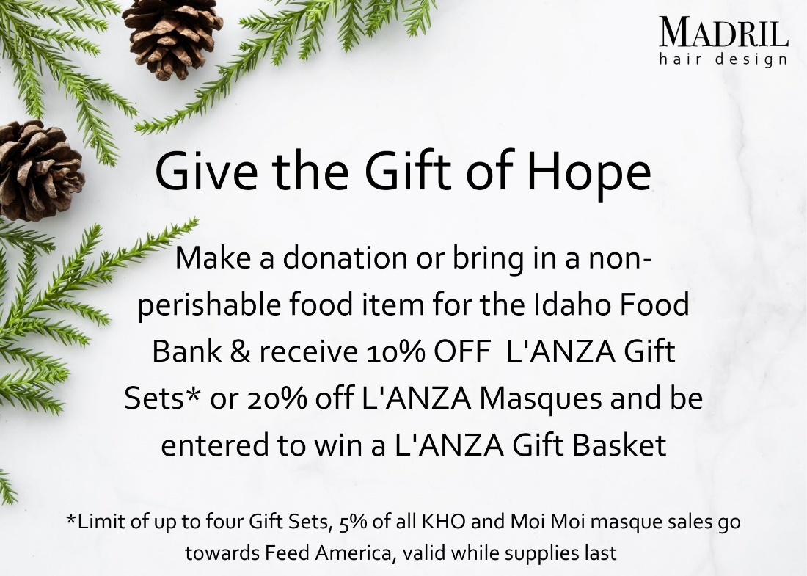
Promotion Title: Holiday Food Donation
Month: Nov/Dec
Start date: Nov. 27th - Dec. 20th
Category (internal/external): Internal & External
Description: Bring in any non-perishable food item to receive 10% off the purchase of a L’ANZA Holiday Gift Set and be entered to win a L’ANZA Gift Basket.
What: Buy a Holiday Gift Set and be entered to win a L’ANZA Gift Basket. If a guest brings in a non-perishable food item for the Idaho Food Bank or makes a donation (suggest at least $5) they will receive 10% off L’ANZA Gift Sets or 20% off KHO and Moi Moi masques.
  - Guest Incentive: “Holiday Gift Sets and Masques”
    - Guests receive 10% off L’ANZA Gift Sets and 20% off KHO and Moi Moi Masques when they contribute to the Idaho Food Bank
    - Guests will be entered to win a L’ANZA Gift Basket when they purchase L’ANZA Gift Sets
    - 5% of all KHO and Moi Moi Masque sales goes to Feed America
  - Stylist Incentive: “Holiday Gift Sets and Masques”
    - See stylist Promo below that sells the most CBD retail will win a set of the new CBD line from L’ANZA (must sell at least 26 products to qualify, that is only 3 CBD products a week over an 8 week period)
  - Rules:
    - Must donate at least $5 to qualify
    - Guests are limited to four gift sets/entries per visit
    - While supplies last
  - Instructions:
    - There will be a Food Bank button under Services
    - Use this button to ring up donations
    - Guests do not have to buy retail to donate
    - Ask guests if they would like to donate to the Idaho Food Bank when checking out
    - Use the Holiday 10% discount button to add discount for Holiday Sets
    - Use the Masque 20% discount button to add discount for Masques
  - Winner notified on December 31st at 5:00pm
To Do List:
- Make Signage:
  - Internal = 14 - 5 x 7’s
    - Design = (Team member)
    - Print & Place = (Team member)
  - External = Facebook, Software E-blast, Newsletter, Instagram
    - Facebook Write up/Post = (Team member)
    - Software E-blast = (Team member)
    - Newsletter = (Team member)
    - Instagram = (Team member)
- Make reminder sheets for tribe
    - Type up Instructions = (Team member)
    - Print up promo description and put in a binder for front desk = (Team member)
    - Video for social media = (Team member)
    - Set up donation button in software = (Team member)
    - Set up discount buttons in Phorest = (Team member)
    - Track Sales = (Team member)
    - Pick up donation barrel from Idaho Food Bank = (Team member)
    - Order Gift Sets and Masques = (Team member)
    - Get together items for gift basket = (Team member)
    - Contact Pam for donations = (Team member)
    - Make display for Holiday Gift Sets = (Team member)
- Sign off with date and initials once task has been completed _________
Actual Goal: Help out our community by collecting donations for the food bank. Sell Holiday Gift sets and KHO Masques and Moi Moi Masques for optimum profits
Assigned Individuals:
(Team member) = Signage (Crystal)
(Team member) = Newsletter, Facebook posts, E-blasts, IG stories, tracking
(Team member) = Make videos
(Team member) = Tracking (sales)
(Team member) = Display, Instagram, Contact Pam for donations for gift basket and gathering other things to put in basket, order product
(Team member) = get Idaho Food Drive barrel
Resources:
  - Distributor
  - Brand Consultant
  - Adobe suite
  - Canva
  - Premiere – Instagram planner
  - Facebook
  - Software
Supplies Needed:
  - Ink
  - Frames

  - Photo paper

  - Gift Card

  - Holiday Decorations

  - Basket

  - Cellophane
Expenses:
  - Ink $10
  - Photo paper $6.45
  - Adobe Suite
  - Cellophane $1
  - Cost of Products $1360
Total expense = $1376.45
Incentive: 10% off Holiday Gift Sets, 20% off Masques, helping out the community
Assigned Progress Tracker: ____________________________

Retail – Flash Sale
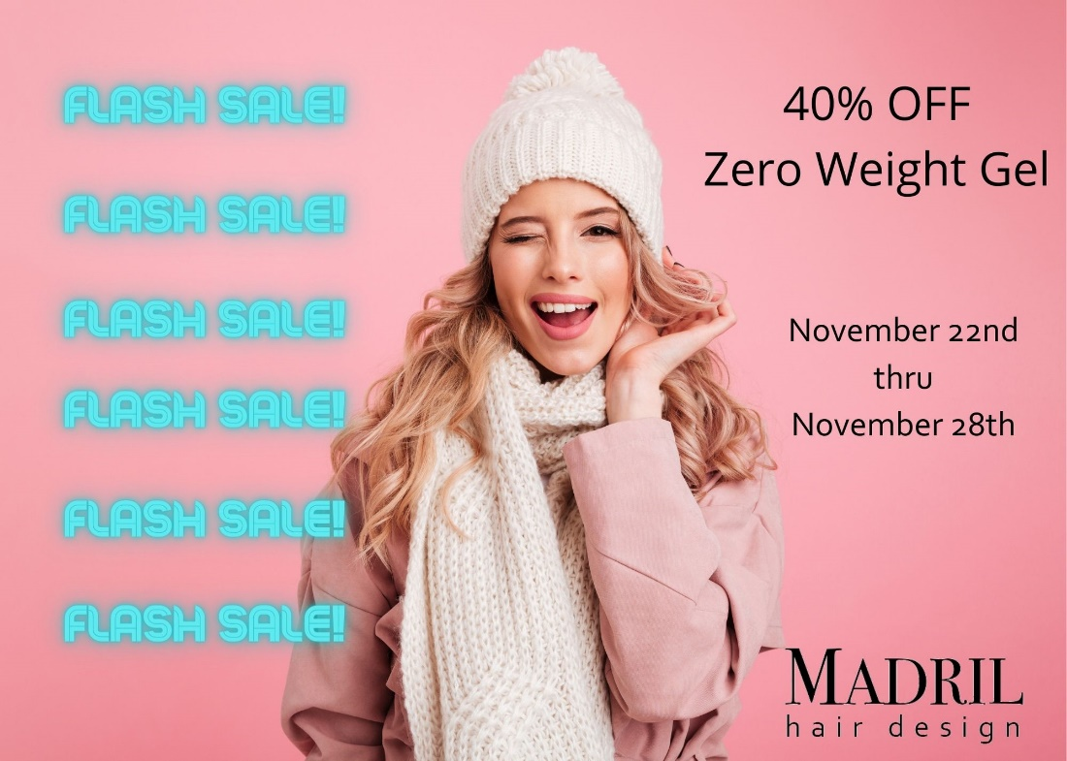
Promotion Title: Zero Weight Flash Sale
Month: Nov/Dec
Start date: Nov. 22nd
End date: Nov. 28th
Category (internal/external): Internal & External
Description: 40% off Zero Weight Gel for one week only.
What: Flash sale to create urgency. We are receiving 50% off from our distributor and selling it at 40% off normal retail price.
To Do List:
- Make Signage:
  - Internal = 14 - 5 x 7’s
    - Design = (team member)
    - Print & Place = (team member)
  - External = Facebook, Software E-blast, Newsletter
  - External = Facebook, Software E-blast, Newsletter, Instagram
    - Facebook Write up/Post = (team member)
    - Software E-blast = (team member)
    - Newsletter = (team member)
    - Instagram = (team member)
- Track Sales = (team member)
- Order Product = (team member)
- Sign off with date and initials once task has been completed _________
Actual Goal: To make a higher profit by selling product we buy at 50% off to guests at 40% off regular retail price
Assigned Individuals:
(Team member) = Signage (Crystal)
(Team member) = Newsletter, Facebook posts, E-blasts, IG stories, tracking
(Team member) = Make videos
(Team member) = Tracking (sales)
(Team member) = Display, Instagram, order product
Resources:
  - Distributor
  - Brand consultant
  - Adobe suite
  - Canva
  - Premiere – Instagram planner
  - Facebook
  - Software

Supplies Needed:
  - Ink
  - Frames
  - Photo paper
  - Holiday Decorations
  - Bags
  - Colored Tissue Paper
Expenses:
  - Ink $10

  - Photo paper $6.45

  - Adobe Suite

  - Cellophane $1

  - Tissue Paper $1

  - Cost of Products $62.30
Total expense = $80.75
Incentive: 40% off
Assigned Progress Tracker: ____________________________

Retail – Flash Sale
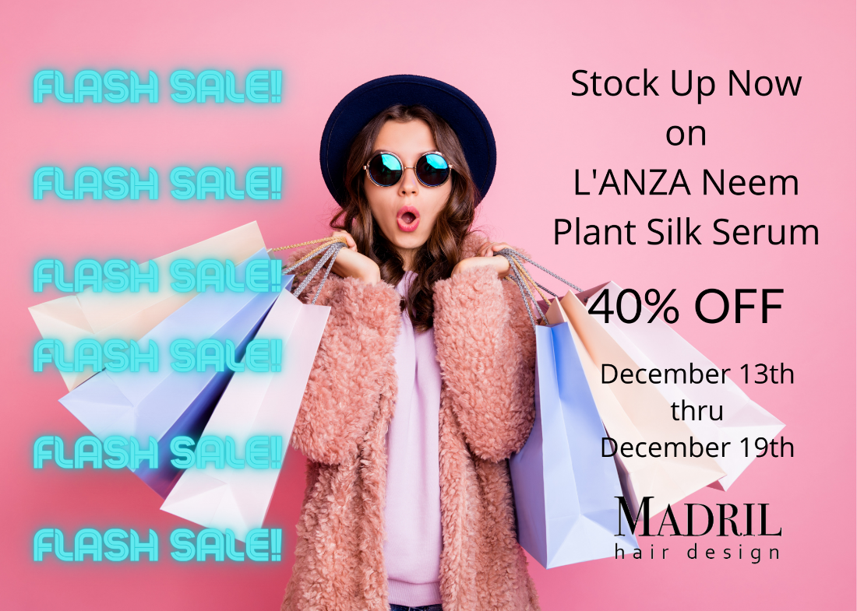
Promotion Title: Neem Plant Silk Serum Flash Sale
Month: December
Start date: Dec. 13th
End date: Dec. 19th
Category (internal/external): Internal & External
Description: 40% off Neem Plant Silk Serum for one week only.
What: Flash sale to create urgency. We are receiving 50% off from our distributor and selling it at 40% off normal retail price.
To Do List:
- Make Signage:
  - Internal = 14 - 5 x 7’s
    - Design = (team member)
    - Print & Place = (team member)
  - External = Facebook, Software E-blast, Newsletter
  - External = Facebook, Software E-blast, Newsletter, Instagram
    - Facebook Write up/Post = (team member)
    - Software E-blast = (team member)
    - Newsletter = (team member)
    - Instagram = (team member)
- Track Sales = (team member)
- Order Product = (team member)
- Sign off with date and initials once task has been completed _________
Actual Goal: To make a higher profit by selling product we buy at 50% off to guests at 40% off regular retail price
Assigned Individuals:
(Team member) = Signage
(Team member) = Newsletter, Facebook posts, E-blasts, IG stories, tracking
(Team member) = Make videos
(Team member) = Tracking sales
(Team member) = Display, Instagram, order product
Resources:
  - Distributor
  - Brand consultant
  - Adobe suite
  - Canva
  - Premiere – Instagram planner
  - Facebook
  - Software

Supplies Needed:
  - Ink
  - Frames
  - Photo paper
  - Holiday Decorations
  - Bags
  - Colored Tissue Paper
Expenses:
  - Ink $10

  - Photo paper $6.45

  - Adobe Suite

  - Cellophane $1

  - Tissue Paper $1

  - Cost of Products $107.60
Total expense = $126.05
Incentive: 40% off
Assigned Progress Tracker: ____________________________

Retail –Stylist Incentive
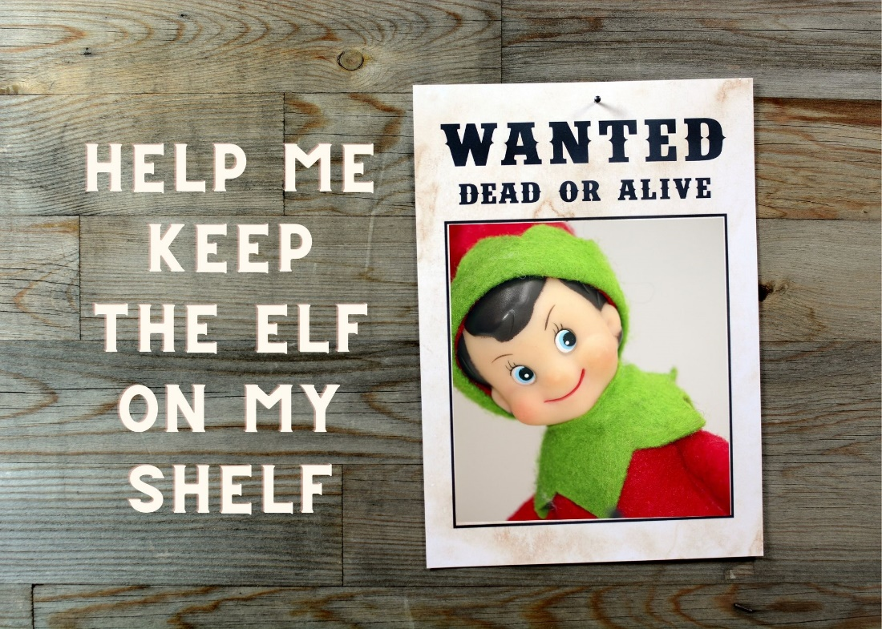
Promotion Title: Elf on the Shelf
Month: Nov/Dec
Start date: Nov. 15th
End date: Dec. 31st
Category (internal/external): Internal
Description: Every time a technician sells a retail product, they get the elf to sit on THEIR shelf. Our distributor sales consultant, (name), will call randomly ever week and whoever has the elf on their shelf wins a prize. The stylist who has the highest retail sales will win a grand prize.
What: All prizes are being donated by distributor & manufacturer. (Reach out and ask)
To Do List:
- Make Signage:
  - Internal = 14 - 5 x 7’s
    - Design = (team member)
    - Print & Place = (team member)
  - External = Facebook, Instagram
    - Facebook Write up/Post = (team member)
    - Instagram = (team member)
- Track Sales = (team member)
- Sign off with date and initials once task has been completed _________
Actual Goal: Incentivize service providers to sell retail and gather interest from guests to help incentivize more retail sales
Assigned Individuals:
(Team member) = Signage
(Team Member) = Facebook posts, IG stories
(Team member) = Make videos
(Team Member) = Tracking (sales)
(Team Member) = Display, Instagram
(Team member) = random calls/prizes
Resources:
  - DSC
  - Brand consultant

Supplies Needed:
  - Ink
  - Frames
  - Photo paper
  - Elf on the Shelf - Crystal
Expenses:
  - Ink $10

  - Photo paper $6.45
Total expense = $16.45
Incentive: Prizes!!!
Assigned Progress Tracker: ____________________________

Christmas Joy!
Promotion Title: Holiday Gift Wall
Month: Dec
Start date: Dec. 1st
End date: Dec. 23rd
Category (internal/external): Internal
Description: Guests will pick an ornament upon entering salon and receive their gift, stylists will receive credit for the free haircut. We will be introducing it to give back and the promotion will run for the month of December.
What:
Christmas Joy!
Holiday gift tree or gift wall for non-religious connotations
- 6 prizes, varied value. Number the ornaments
- Whatever ornament they pick corresponds to a prize they will receive day of
- Ultimate treatment x 2
- 10% off retail x 10
- 20% off retail x 5
- Free haircut w/color service x1
- 5 dollars off in salon treatment x 5
- 10 dollars off luxury in salon treatment x 4
- Free travel size with full size purchase x 3
To Do List:
- Make Signage:
  - Internal = 14 - 5 x 7’s
    - Design = (team member)
    - Print & Place = (team member)
  - External = Facebook, Software E-blast, Newsletter
    - Write up/Post = (team member)
- Track = (team member)
- Sign off with date and initials once task has been completed _________
Actual Goal: Improve guest experience and relations, promote long term clients
Assigned Individuals:
Resources:
Supplies Needed:
Expenses:
Assigned Progress Tracker: ____________________________

Attitude of Gratitude - On Christmas day our guests will receive an email and/or text message thanking them for their loyalty, and it will include a promotion code for a free ultimate treatment, redeemable JAN 1- FEB 28. (The goals is to upsell them to one of our two premium treatments, the Emergency Service or KHO Hot Oil Treatment)

Holiday VIP gifts
Top twenty Guests plus each stylists’ top client will receive a travel-size KHO Shampoo, Conditioner, and Treatment Oil in a cute gossamer bag with some dove chocolate with a signed Holiday Card. (Have everyone’s signature digitally put on a file for future use). Possibly add bracelet ($0.49)

